American coins

value | coin name | heads | tails
50 ¢ | half dollar /  50-cent piece | 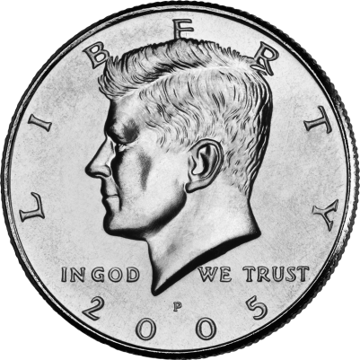  Figure 1: Kennedy (1961-1963) | 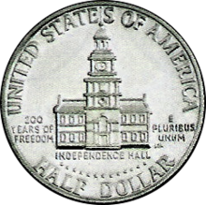
25 ¢ | quarter | 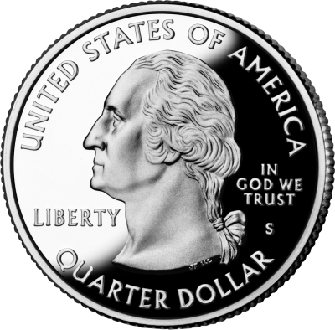  Figure 2: Washington (1789-1797) | 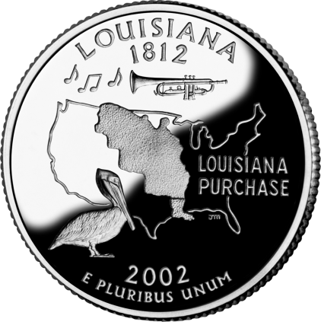
10 ¢ | dime | 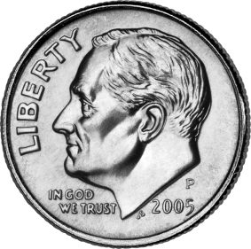  Figure 3: Roosevelt (1933-1945) | 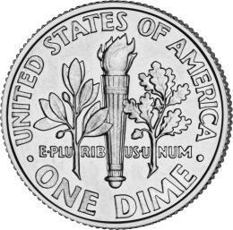
5 ¢ | nickel | 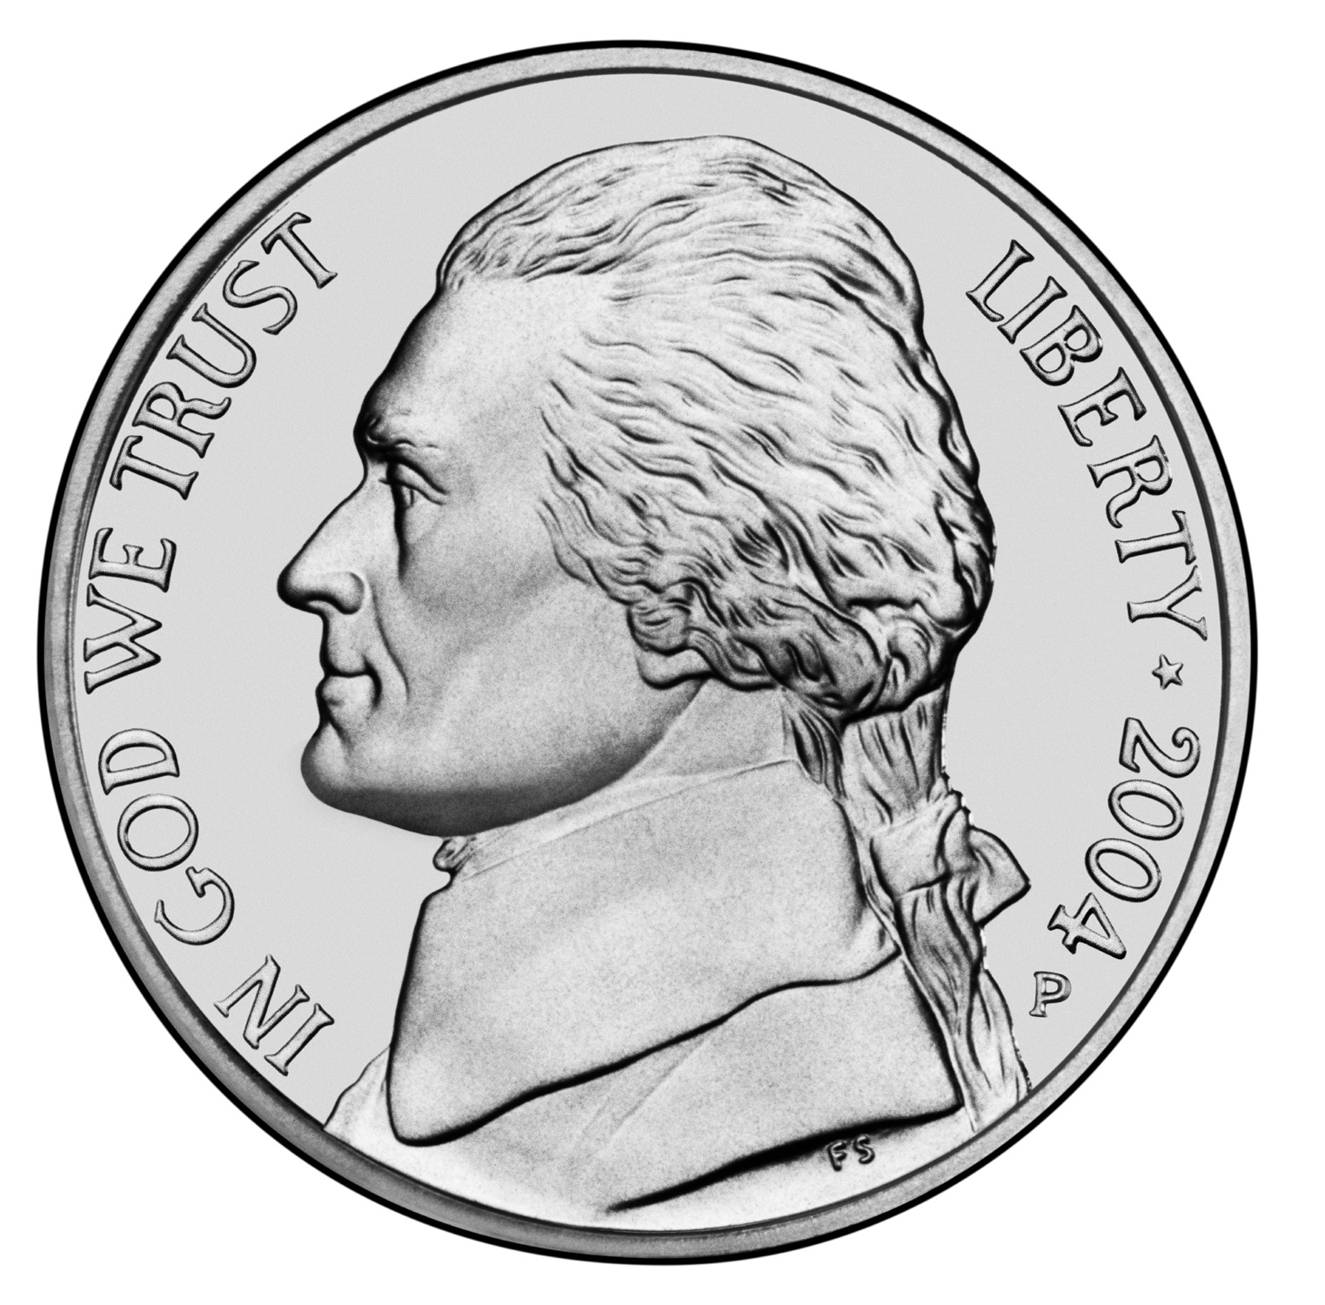  Figure 4: Jefferson (1801-1809) | 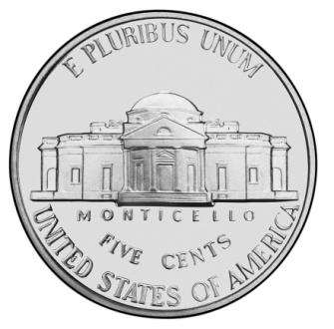
1 ¢ | penny / cent | 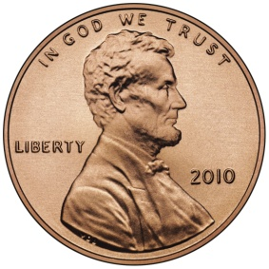  Figure 5: Lincoln (1861-1865) | 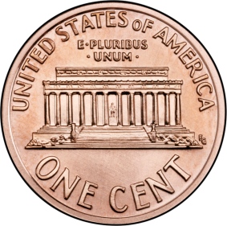

Looking at the coins
1. How do you think you say "pile ou face" in English?

2. What words are there on all of the heads?

3. What words are there on all of the tails?

Presidents and Dates
John Kennedy was President from 1961 (nineteen sixty-one) to 1963 (nineteen sixty-three).

George Washington was President from 1789 (_________________ ____________ - _______)

to 1797 (____________________ ___________ - ___________)

Abraham Lincoln was president from 1861 (_________________ ____________ - _______)

to 1865 (____________________ ___________ - ___________): from the beginning to the end of the Civil War.

Fractions
¼ one _____________

½ one _______

¾ three quarters

More on the website!
http://www.creoliste.fr/6e

