1)  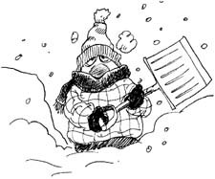 |  | 2)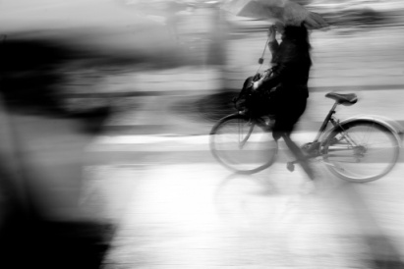
 | 3)  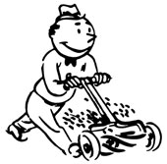 |  | 4)  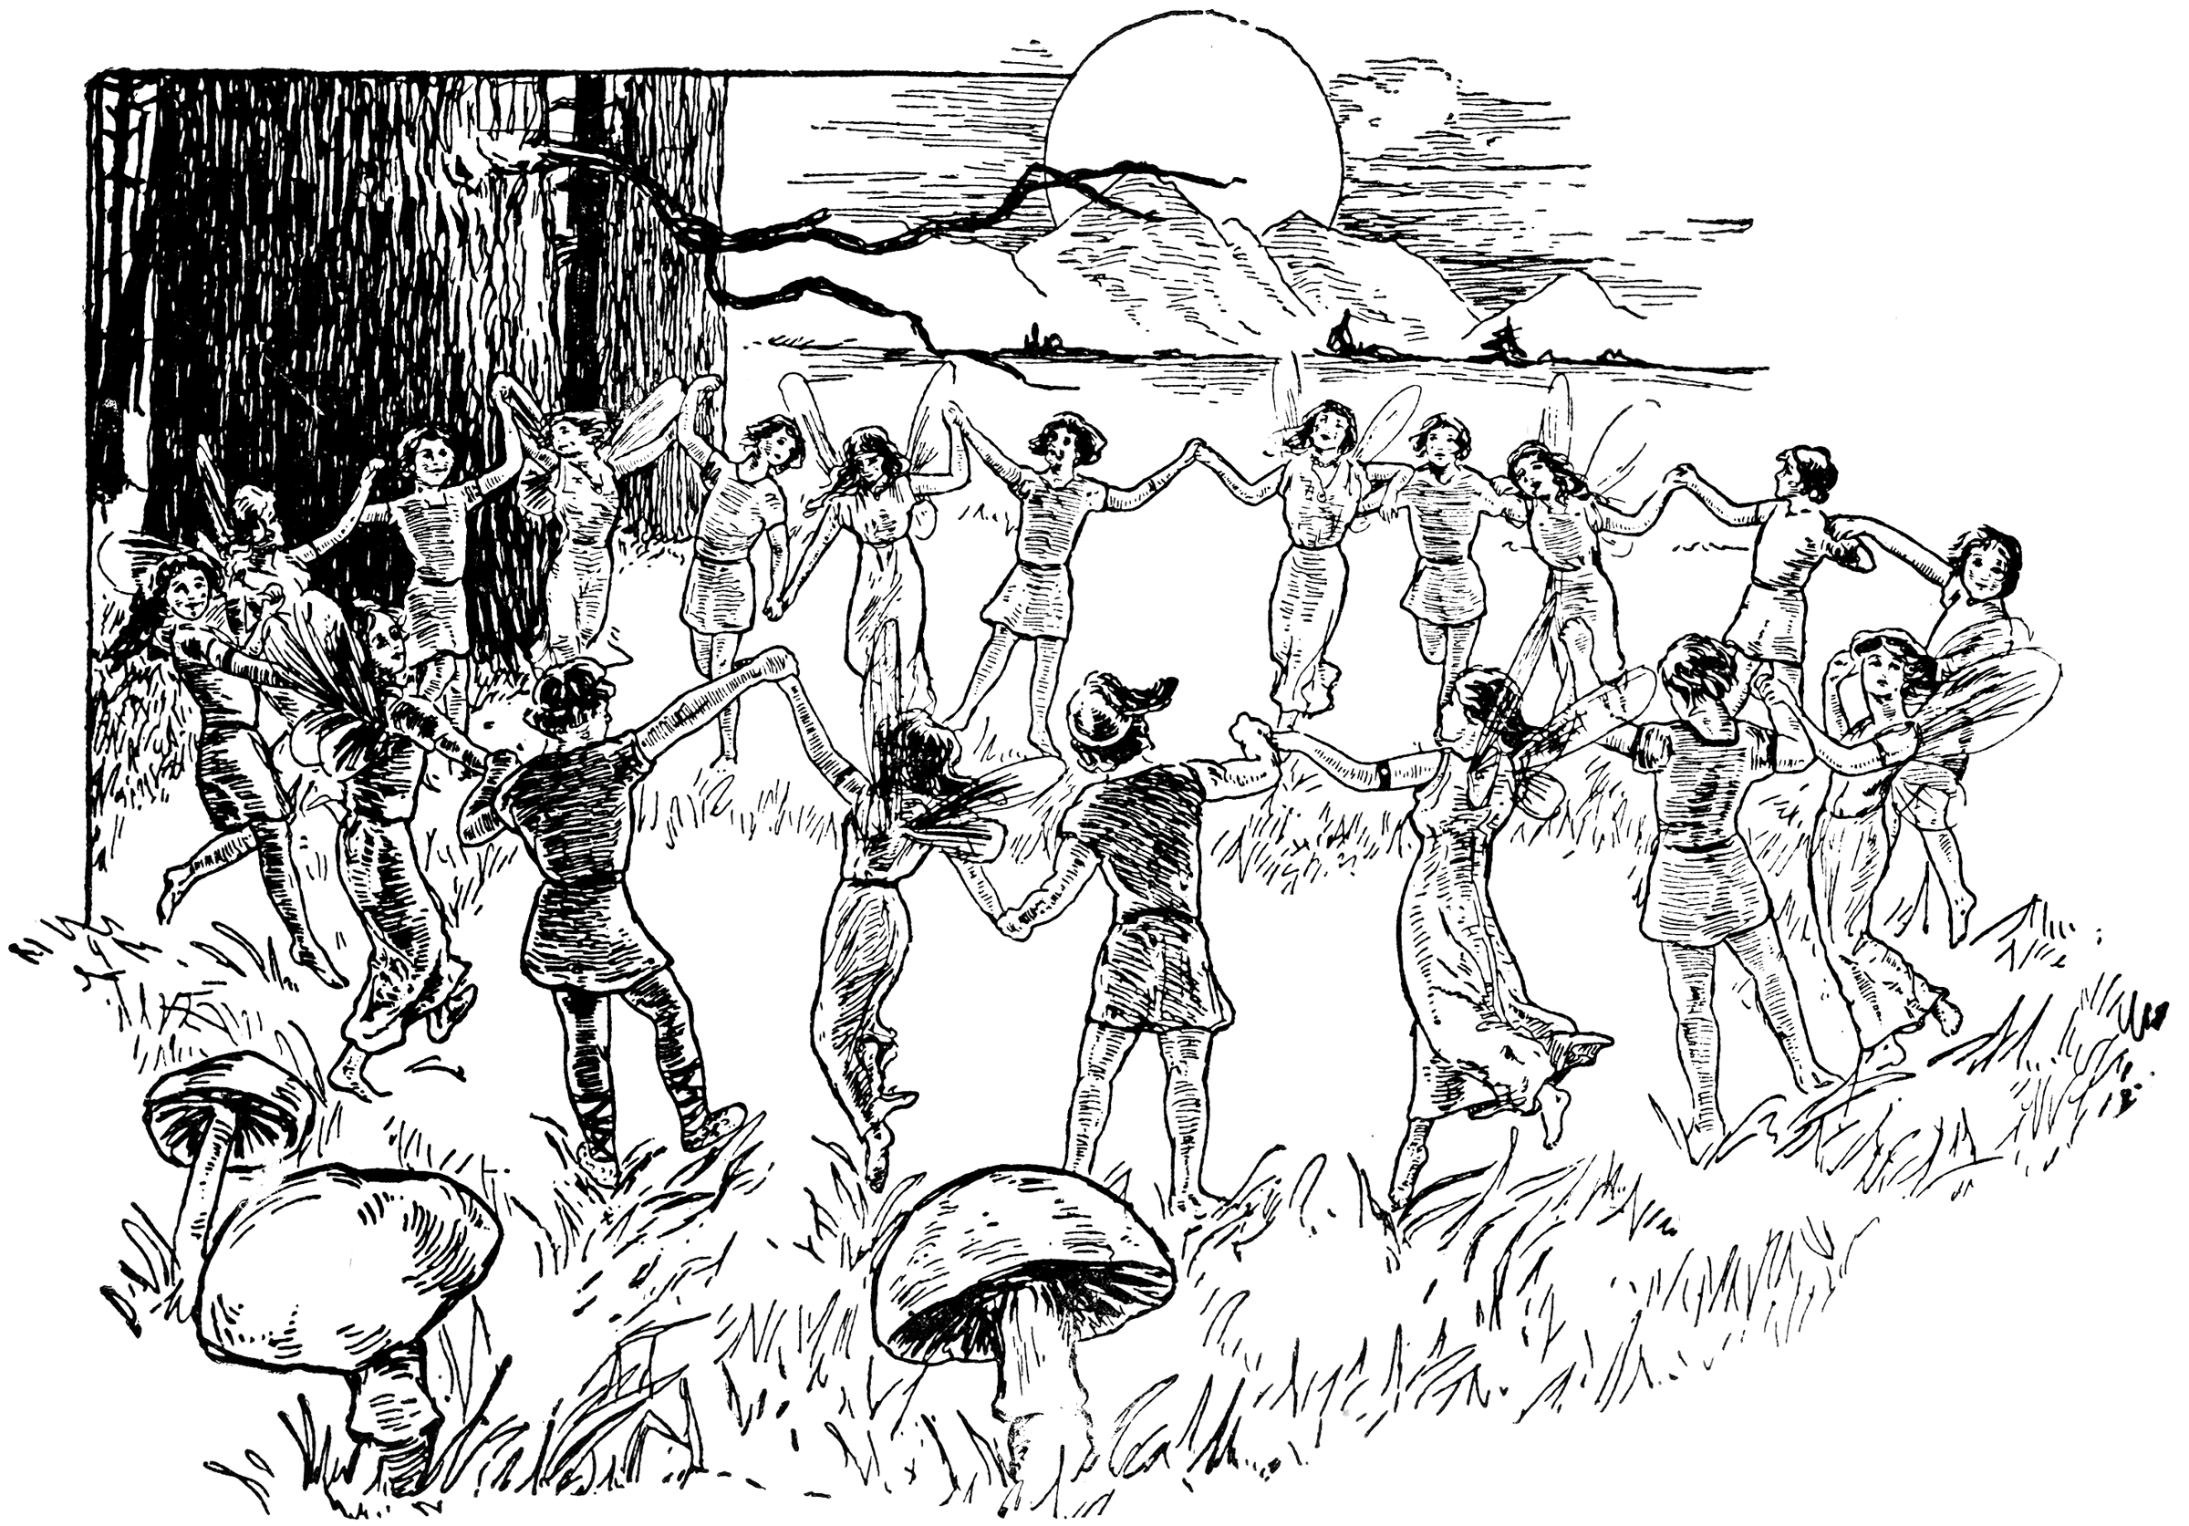
5)  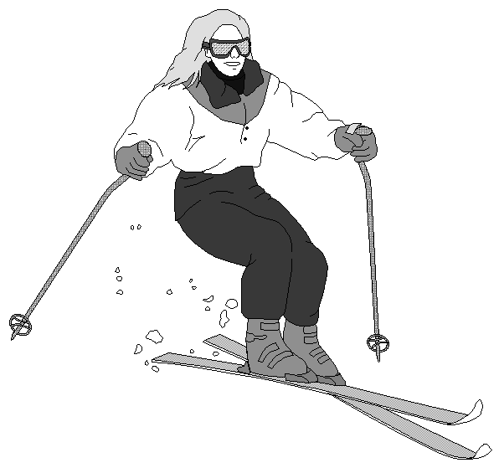 |  | 6)  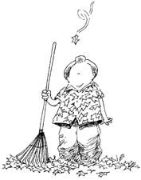
 | 7)   |  | 8)  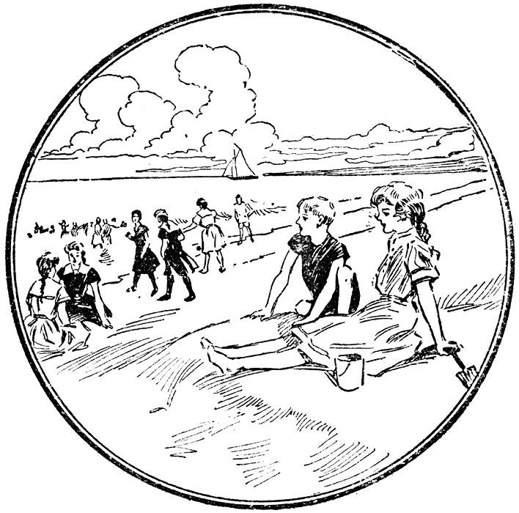
9)  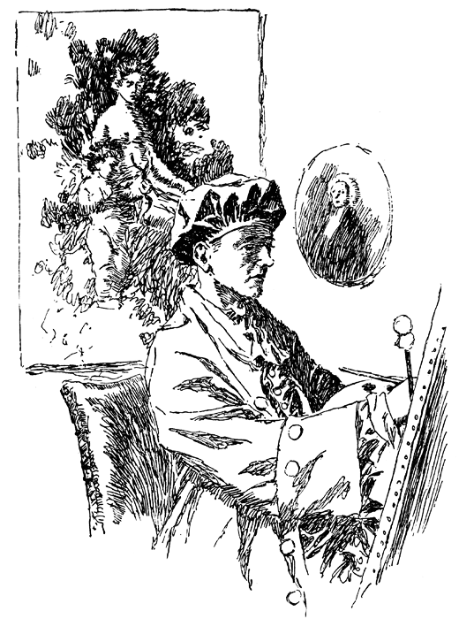 |  | 10)  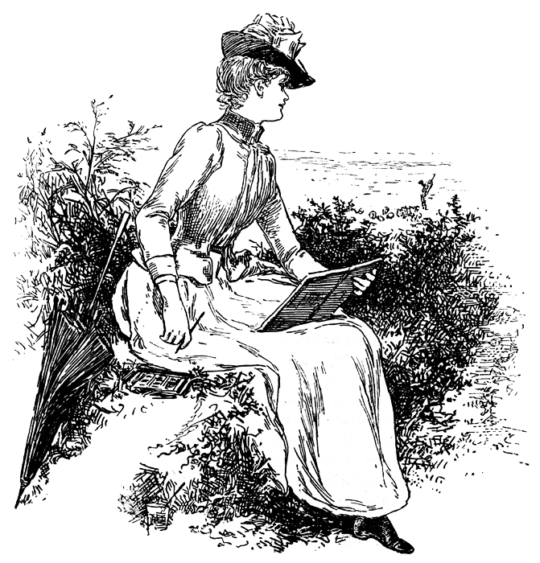
 | 11)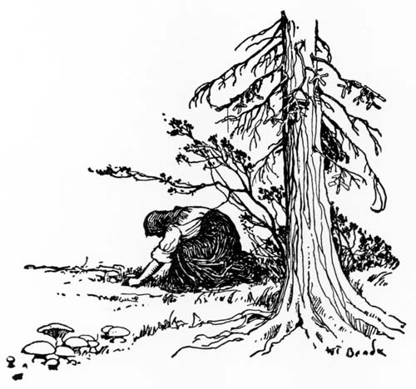 |  | 12)  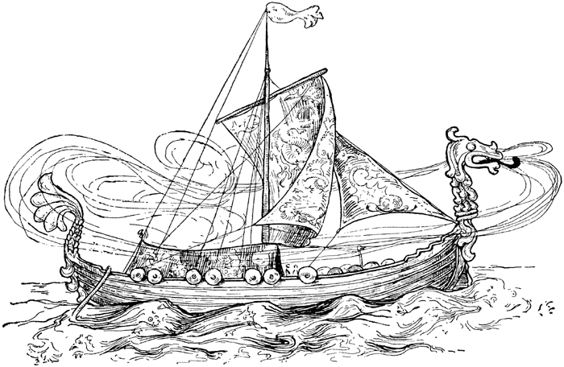
13)  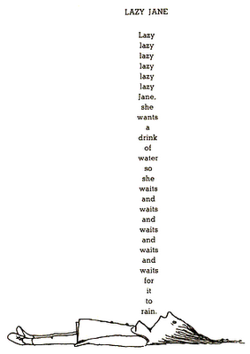 |  | 14) 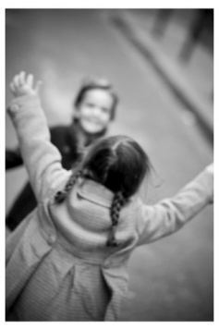

Activities

Instructions: Cut out the images on page one. On the back of each image, write the name or names of the activity.

being lazy (13)

doing housework (7)

doing yardwork (6, 3)

skiing (5)

painting (9)

relaxing at the beach (8, 10)

raking leaves (6)

dancing in the woods (4)

traveling (12)

sketching (10)

mowing the lawn (3)

shoveling snow (1)

vaccuuming (7)

sunbathing (8)

digging out in winter (1)

giving hugs (14)

riding my bike in the rain (2)

seeing old friends (14)

gathering mushrooms (11)

drawing (10)

Likes / Dislikes
Instructions, underline the word ending in -ing. Circle the word just before.

♥ | ♡
I like reading in bed. | I don't like reading on an I-phone
She really likes traveling. | They really don't like skiing at all.
I like painting best in spring | She doesn't like doing yardwork in fall.
I love being lazy in summer | I'm not too keen on riding my bike in the rain.
I'm fond of sledding. | I can't stand doing housework in any season.

Now say what YOU like and don't like...

